**RETURN PACKAGING AND SHIPPING INSTRUCTIONS**

**FOR AFM BIOREPOSITORY SAMPLES TO FISHER BIOSERVICE LAB (Acute Specimen Collection Kit)**

**NOTE: SHIPMENTS TO FISHER BIOSERVICES SHOULD BE MADE MONDAY – THURSDAY ONLY**

**NOTE: WHEN KIT IS RECEIVED, REMOVE GEL PACKS AND PLACE IN REFRIGERATOR.**

**NOTE: DO NOT REMOVE STYROFOAM SHIPPER FROM OUTER CARDBOARD SHIPPER BOX.**

**NOTE: INCLUDED ARE TWO PLASTIC 95 kPa BAGS WITH ABSORBENT SLEEVES AND TWO 6x6” PLASTIC BAGS FOR SAMPLE RETURN**

1. Remove white (4 place) absorbent sleeve from one of the plastic 95 kPa bag (**Picture 1**).
2. Place the 6ml Red Top tube into one slot of (4 place) absorbent sleeve. (See **Picture 2** below)
   1. 1 x 6ml Red Top (for Children) OR 1 x 10 ml Red Top (for Adults)

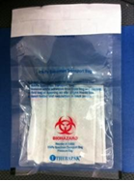

Picture 1

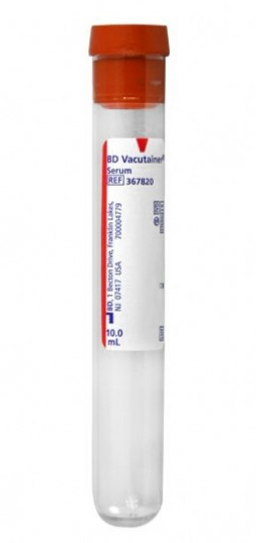

Picture 2

1. Place Nasal swab and Universal Viral Transport(UVT) (**Picture 3**) into an open slot of the same (4 place) absorbent sleeve. (If nasal wash is not collected)

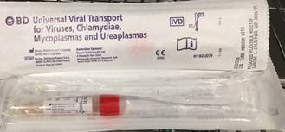

Picture 3

1. Place Rectal Swab and Transport Media (**Picture 4**) into an open slot of the (4 place) absorbent sleeve. (Only if stool specimen is not collected)

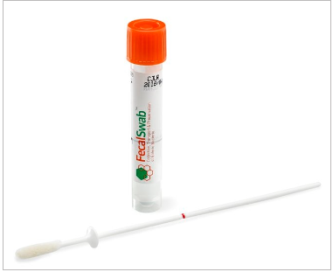

Picture 4

**Note: The Red Top Tube, UVT Swab, and Rectal Swab will all go into the same 4 place tube holder and placed into the first**

**95 kPa bag.**

1. Place Stool Specimen Container (**Picture 5**) into the first 6” x 6” clear plastic bag and place this into the first 95 kPa bag. (if stool specimen is collected then no rectal swab).

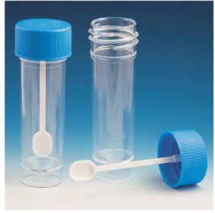

*Picture 5*

1. Place any CSF Samples – Cryovial samples (**Picture 6**) into the second 6” x 6” clear plastic bag and place this into the first 95 kPa bag.

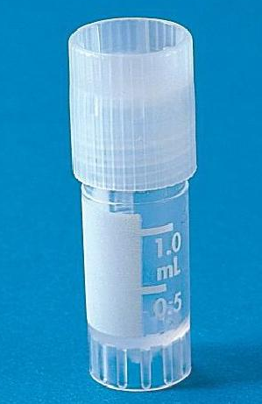

*Picture 6*

**Note: The stool samples in a plastic bag and the CSF Samples in a plastic bag will be placed inside the same 95 kPa bag as the Red Top Tube, UVT Swab, and Rectal Swab. Seal the biohazard 95 kPa bag and place into the insulated shipper.**

1. Place the 2 Gel Packs (**Picture 7**) on top of the first 95 kPA bag in the insulated shipper. **Note: These gel packs should be preconditioned in the refrigerator**

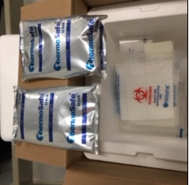

*Picture 7*

1. Remove white (4 place) absorbent sleeve from the second plastic 95 kPa bag. (**Picture 8**)
2. Place the 6ml EDTA Purple Top tube into one slot of (4 place) absorbent sleeve. (See **Picture 9** below)
   1. 1 x 6ml EDTA (for Children) OR 1 x 10ml EDTA (for Adults)

 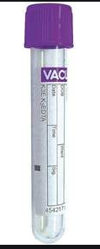

*Picture 8 Picture 9*

1. Place the (4 place) absorbent sleeve with the purple top into the second 95 kPA bag and seal the bag. *Only* the Purple Top Tube will be placed into one slot of the (4 place) absorbent sleeve inside of the second 95 kPa bag. Place the second 95 kPa bag into the metallic insulated mailer (**Picture 10**) and seal closed. Place the metallic insulated mailer on top of the gel packs in the insulated Styrofoam shipper. Fold edges of the metallic insulated mailer to allow for secure fit.

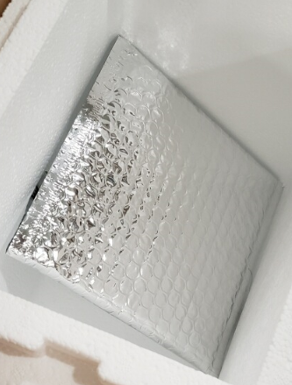

*Picture 10*

1. Close the Styrofoam shipper lid.
2. Place Specimen submission form on top of Styrofoam shipper lid. Close and seal outer carboard shipper box.
3. Place “Exempt Human Specimen” label on the front of shipping box.
4. Write the shipment date on pre-filled FedEx Airway bill.
   1. Keep the top copy of the Airway bill and place remaining copies into Airway bill pouch.
5. Attach Airway bill pouch to top of shipping box.
6. Ship package via Federal Express Priority Overnight by taking to a local FedEx shipping location and have package checked in by a FedEx employee. **DO NOT PLACE IN FEDEX DROP BOX.**